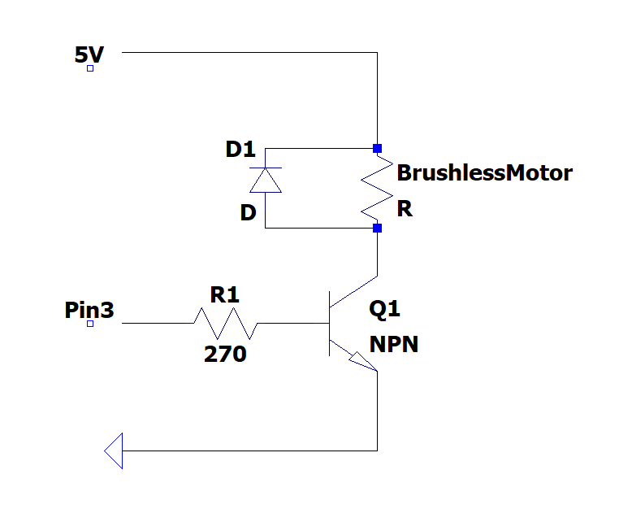

We used a transistor so if pin 3 is high, there will be a flow of current toward the motor and if it is low the motor will be off. The purpose of the diode is to absorb the current when we turn off the motor, so we don't damage the Arduino. Since the motor is small, we can supply it from the Arduino but if it is big, we will need external power supply.

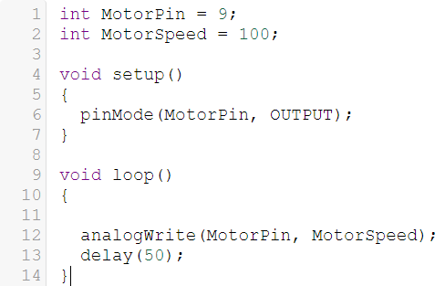First, we define pin # 9 and motor speed. Then, we chose pin # 9 to be output in the void setup. Finally, we write the function that controls the motor speed in the void loop.